Interim Report

Home Automation Using Raspberry Pi

Members:
20 – Deepak J Puthukkaden
31 – Giridhar A K
32 – Govindh B
53 – Rohit Sreekumar
59 – Shine Ali

Introduction

The basic idea of the project is a home automation system using Raspberry Pi at it's centre. The project we are working on basically consists of basic systems that help to automate our everyday chores in our homes. The various modules in our automation system are:
1) Adaptive internal lighting system
2) External lighting system
3) Automatic water pump system
4) Temperature measurement and logging system
5) Password assisted door lock
6) Music player

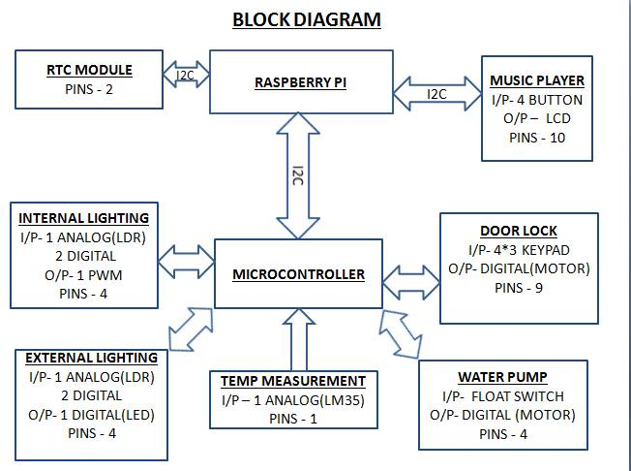

1) Adaptive internal lighting system

Description:
This system as the name suggests adapts to the amount of light present in a room. The intensity of the light source is controlled by the amount of light present in the room. It employs a LDR and the intensity is controlled by Pulse Width Modulation technique which is given to the light source (LED)

Progress:
The design and coding of the system is complete. Now the remaining part is to modify the existing program so as to communicate with the Raspberry Pi from the microcontroller using I2C interface.

Code:
#define alinput A0
#define aloutput 9
#define alinterrupt A1
#define aloverride A2
float alsensor,alvoltage;
int albrightness;
void setup()
{
Serial.begin(9600);
pinMode(alinterrupt,INPUT);
pinMode(aloverride,INPUT);
}
void loop()
{ alsensor = analogRead(alinput); //read the sensor value
albrightness = alsensor / 4; //convert the value from 10-bit resolution to 8-bit res
alvoltage = alsensor * (5.0 / 1024.0); //convert the value into actual voltage range 0-5V
Serial.print("The voltage is: "); //prints the voltage through serial
Serial.println(alvoltage);
analogWrite(aloutput,albrightness); //output the PWM to the LED
while(digitalRead(alinterrupt)) //interrupt function
{ if(digitalRead(aloverride)) //override - ON
analogWrite(aloutput,255);
else //override - OFF
analogWrite(aloutput,0);
}
delay(500);
}

2) External lighting system

Description:
It basically toggles a light source ON and OFF that is placed outside the house according to the amount of light present. If the amount of light present is below a threshold value the light is turned ON and if it is above the threshold it's turned OFF. The intensity is measured using a LDR

Progress:
In this case also the design and the coding of the system is complete. The only part that remains is the modifying of the existing program to interface with the Raspberry Pi using I2C.

Code:
#define elinput A0
#define eloutput 9
#define treshold 500
#define elinterrupt A1
#define eloverride A2

int elsensor,elstate;

void setup()
{
Serial.begin(9600);
pinMode(eloutput,OUTPUT);
pinMode(elinterrupt,INPUT);
pinMode(eloverride,INPUT);
elstate=0;
}

void loop()
{
elsensor=analogRead(elinput);
if((elsensor>treshold) && (elstate==0))
{ digitalWrite(eloutput,HIGH);
Serial.println("External light is ON");
elstate=1;
}
else if((elsensor<treshold) && (elstate==1))
{ digitalWrite(eloutput,LOW);
Serial.println("External light is OFF");
elstate=0;
}
while(digitalRead(elinterrupt)) //interrupt function
digitalWrite(eloutput,digitalRead(eloverride));
Serial.println("External light is ON-Override");

delay(500);
}

Both the above systems employ the same circuit with the only difference being in the usage of pins. The circuit diagram is given below:

3) Automatic water pump system

Description:
It controls the water pump based on water level in the tank by reading the input from two float switches inside the tank. The system has a relay at it's output, which in turn switches a motor ON and OFF according to the level of water in the tank.

Progress:
The coding and the circuit design is complete. Now the remaining part is to modify the code that supports I2C interfacing with the Raspberry Pi and the microcontroller.

Code:
#define pcinput A0
#define pcoutput 9
#define pclinterrupt A1
#define pcloverride A2

int pcsensor,pcstate;
void setup()
{
Serial.begin(9600);
pinMode(pcinput,INPUT);
pinMode(pcoutput,OUTPUT);
pcsensor = digitalRead(pcinput);
pcstate = pcinput;
}

void loop()
{
pcsensor = digitalRead(pcinput);
if(pcsensor!=pcstate)
{
if(pcsensor == 1)
{ digitalWrite(pcoutput,HIGH);
Serial.println("Motor is ON");
pcstate = pcsensor;
}
else
{ digitalWrite(pcoutput,LOW);
Serial.println("Motor is OFF");
pcstate = pcsensor;
}
}
while(digitalRead(pcinterrupt)) //interrupt function
digitalWrite(pcoutput,digitalRead(pcoverride));
delay(500);
}

Circuit Diagram:

4) Temperature measurement and logging system

Description:
The system basically measures the temperature of the sorrounding using a LM35 temperature sensor which produces an analogue output voltage that is fed into the ADC port of the microcontroller. The microcontroller then measures the voltage level and determines the temperature outside. The data is then send over I2C to the Raspberry Pi, where it'll get stored with the time, for further use.

Porgress:
The program that measures the input voltage from the sensor and convert it into temperature value is completed. Also I2C interfacing has been partially successful . The remaining part is to completely get the I2C result.

5) Password Assisted Door lock

Description:
This system basically consists of a keypad to enter a password and a lock that gets activated upon entering the correct password. It has a 4x3 kepad as the input. The output is a motor that fastens and unfastens a lock corresponding to it's direction of motion.

Progress:
The software and the hardware desing is under development.

7) Music System

Description:
It is a music system based on Raspberry Pi that has button controls like play, pause etc and is used to play music. The music can be loaded from a pen drive or that already stored inside the Raspberry Pi.

Progress:
The software is being developed in python and only half of the portion is complete. The hardware is relatively simple in this case and can be easily developed as soon as the software part is complete.

The summary of the completed and to-complete tasks is as follows:

Tasks Completed:
- Programmed and tested adaptive internal lighting system successfully
- Programmed and tested external lighting system successfully
- Programmed and tested automatic water pump system successfully
- Programmed and tested temperature measurement using LM35 temperature sensor successfully
- The Raspberry Pi was installed with the operating system and other required software's and was configured accordingly
- Interfaced Raspberry Pi and the microcontroller using I2C interface successfully
- The interface program between the Raspberry Pi and the microcontroller was partially successful

Tasks to complete:
- Program and test password assisted door lock system
- Debug the I2C interfacing betweeen the Raspberry Pi and the microcontroller and get the complete output
- Interface Real Time Clock with the Raspberry Pi using I2C interface
- Build the musical system on the Raspberry Pi
- Set up the final relay driver circuit and also the casing

Conclusion:
About 65% of the total work on our project has been completed as of now and the remaining 35% will be completed well in advance of the submission date and there will be ample time to debug any errors that may arise in the course of progress.

